1. After opening the game (for instructions find the "Run Game Instructions" in documents page of our GitHub) you will see a knight walking and you should click the screen (prompt text will tell you to click screen). (Image example below)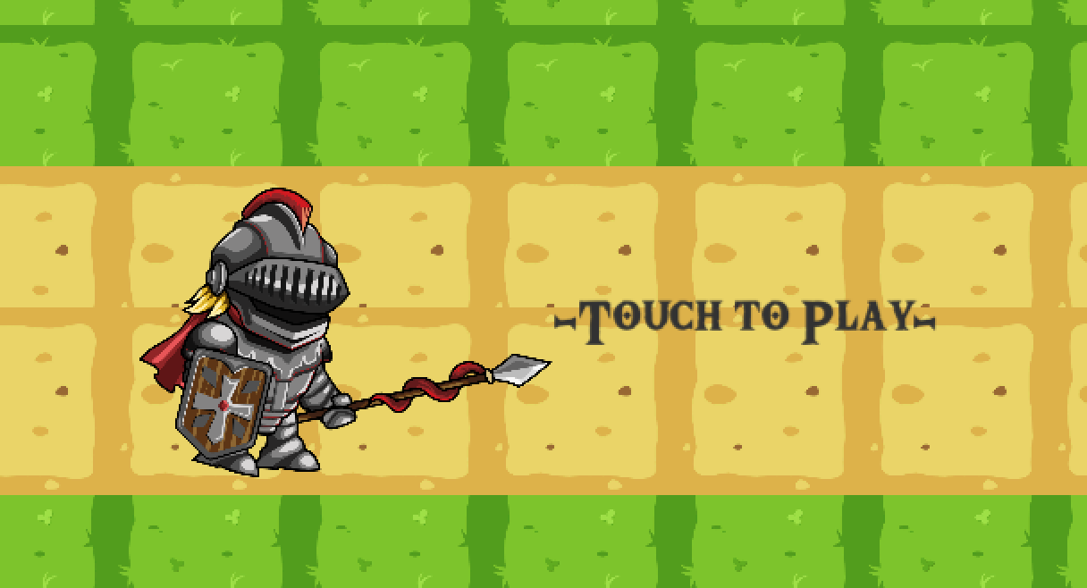
2. You will then see a knight talking to you. To acknowledge his instructions, click the arrow. (Image example below)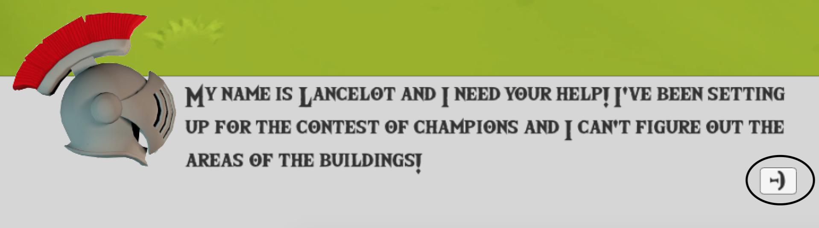
3. Upon reading this the user will be prompted to answer the area of a square. Type an answer and click submit. (Image example below)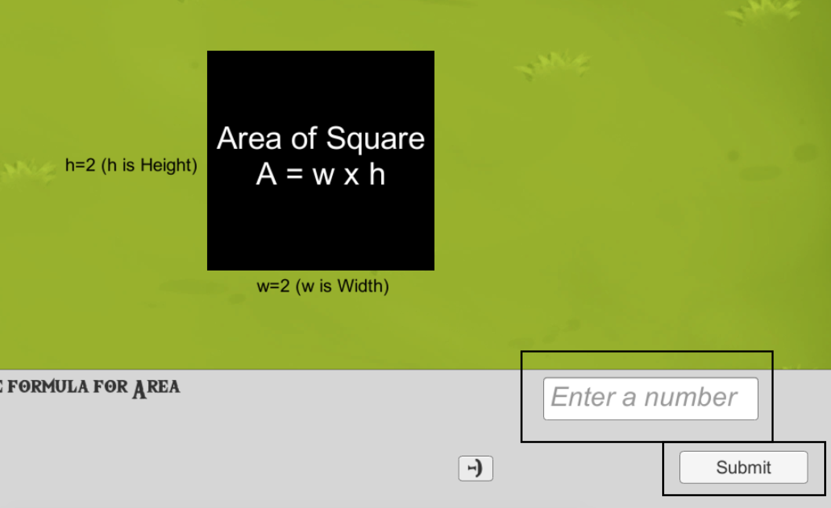
4. If failed, you will be prompted to try again. (Image example below)

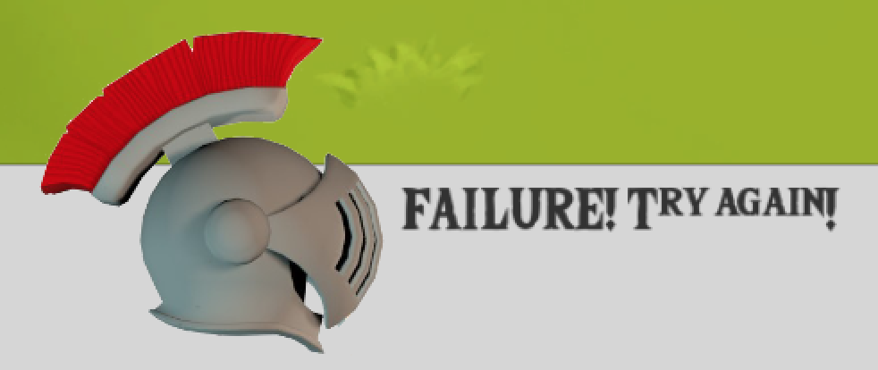

1. Upon correct answer, a triangle will appear and then after getting the correct area for a triangle, a circle will appear. 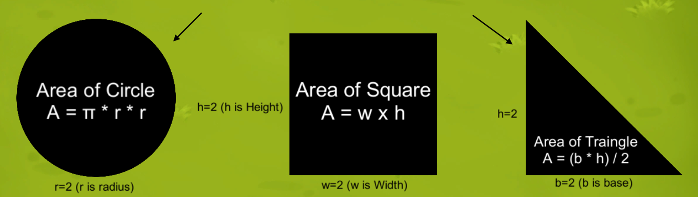
2. With completion of all three of these base shapes, Lancelot will give new instructions with a compound shape appearing. (Image example below)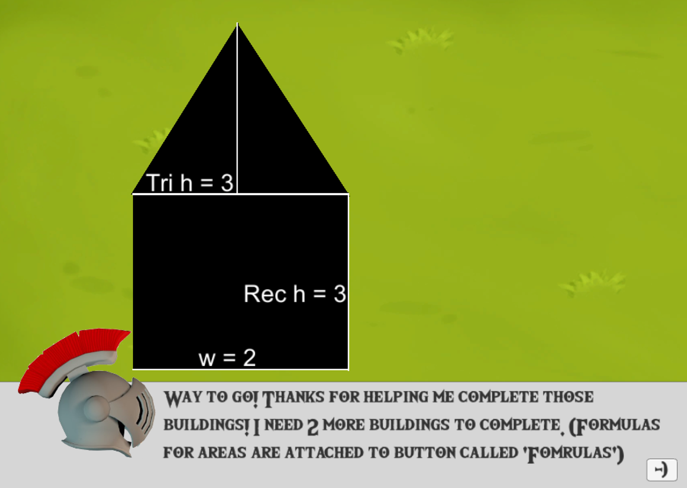
3. You will also see a formula button by the submit button which will help remind you of shapes and their formulas. (Image example below)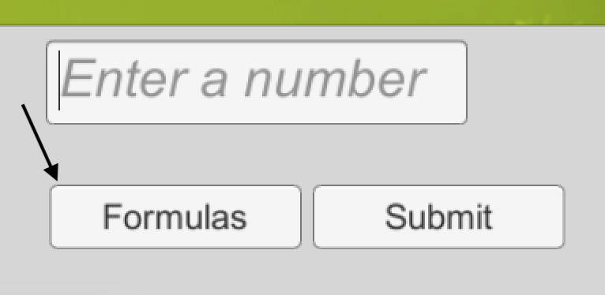
4. Formula sheet will open and give instructions for people trying to solve the compound areas by giving showing formulas for regular shapes areas and helpful hints. (Image example below)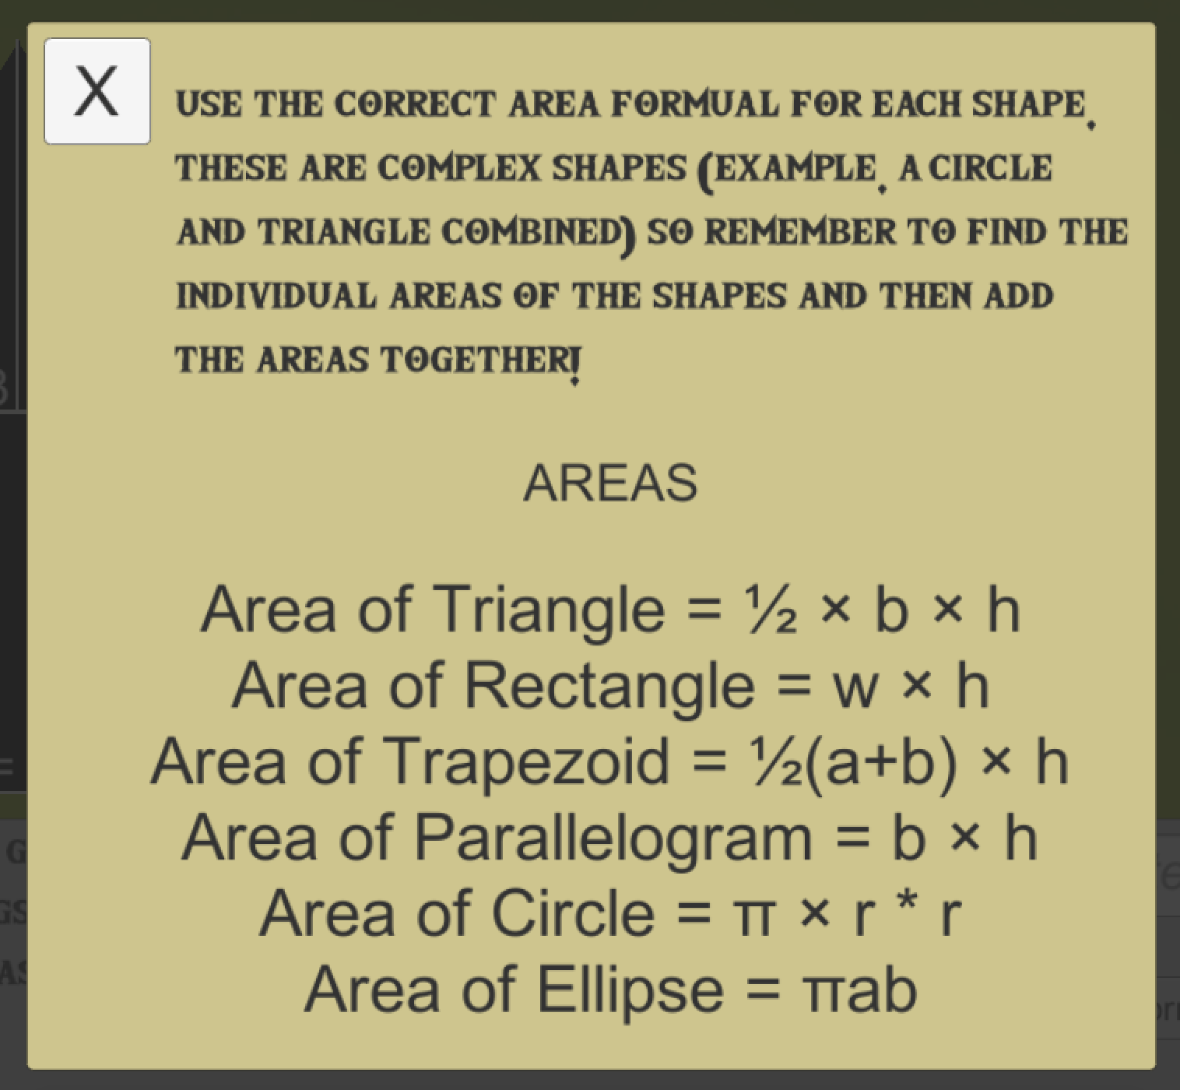
5. Once you answer the questions correctly on the compound shapes section of finding areas, you will be taken to a new screen with Lancelot telling you to join the competition. Click the arrow to acknowledge the reading. (Image example below)

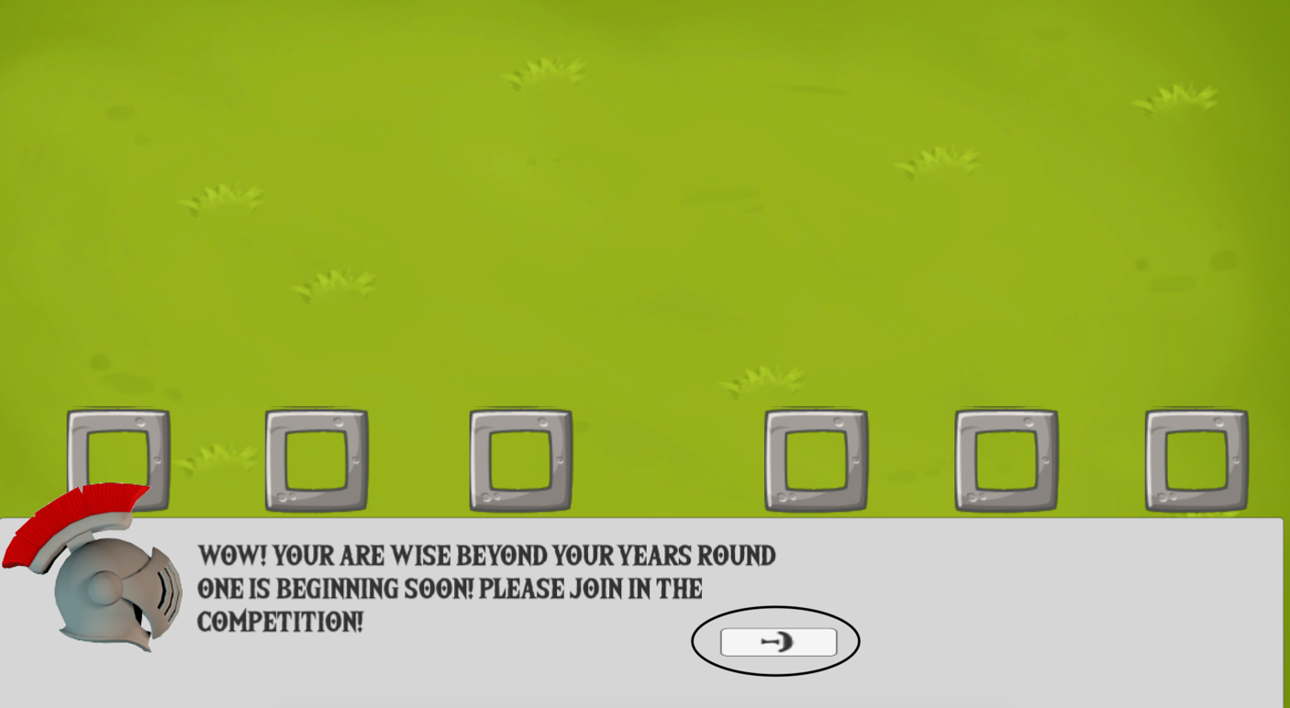

1. You will then be prompted with more instructions from Lancelot on how to compete in the first round of the competition. Click the arrow again to acknowledge the reading. (Similar to step 9)
2. You will then be told to find the distance between the target and the dummy with the catapult starting at zero. (Image example below)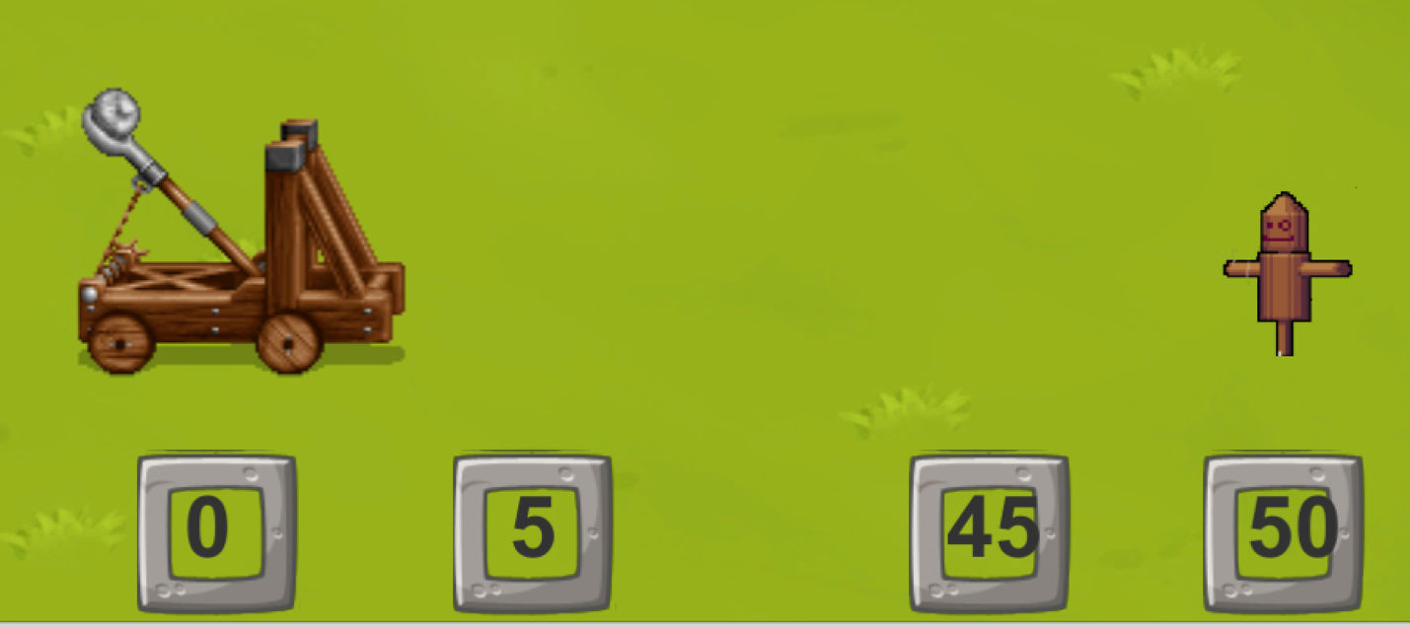
3. Find distance and submit the answer in the submit box area (similar to what was shown in step 3).
4. Lancelot will inform you that you are correct (if correct). Click the arrow button and then repeat the process of step 11 and 12 for a total of five times. (Image example below)
5. Next, you will be advanced to a harder kind of level and the catapult will no longer start at zero. (Image example below) 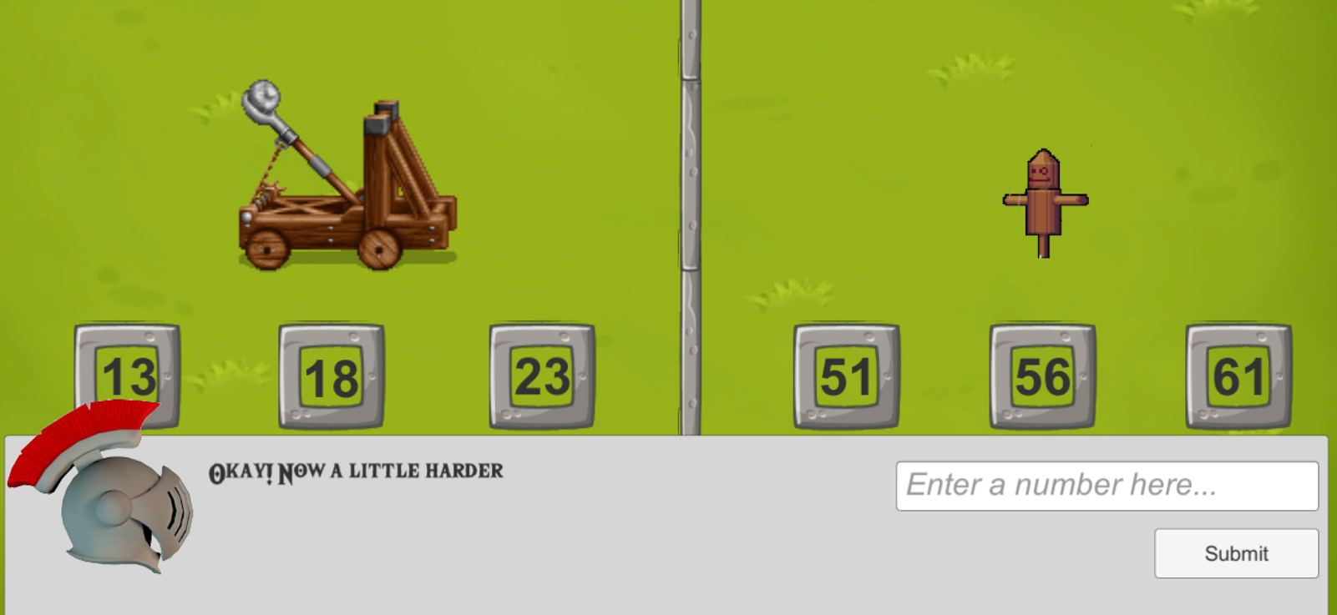
6. Repeat the process of finding the distance and target and the catapult. Submit the distance and acknowledge Lancelot telling you that you got the right answer. Repeat a process similar to 11-13 a total of five times.
7. Next you will be advanced to an even harder kind level and the catapult will have negative numbers involved. (Image example below)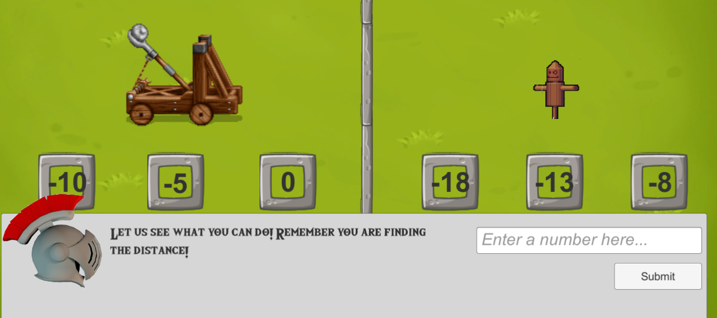
8. Repeat the process of finding the distance and target and the catapult. Submit the distance and acknowledge Lancelot telling you that you got the right answer. Repeat a process similar to 11-13 a total of five times.
9. After this, you will then be prompted by Lancelot to complete another task. Read Lancelot’s instructions and then click the boxes that make 1 full circle and craft a round table. (Image example below)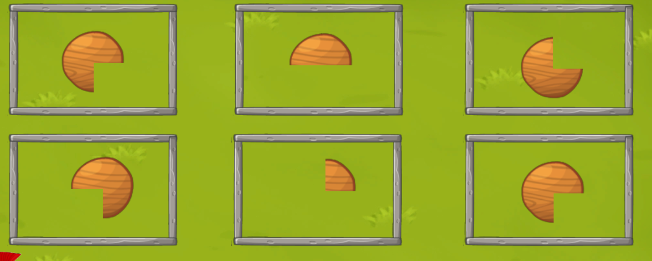
10. You will create multiple round tables and perform a similar process to step 18.
11. Upon completion, a new mini game will appear, and this will be a horse race course where you will read Lancelot’s instructions and acknowledge them. (Image example below) 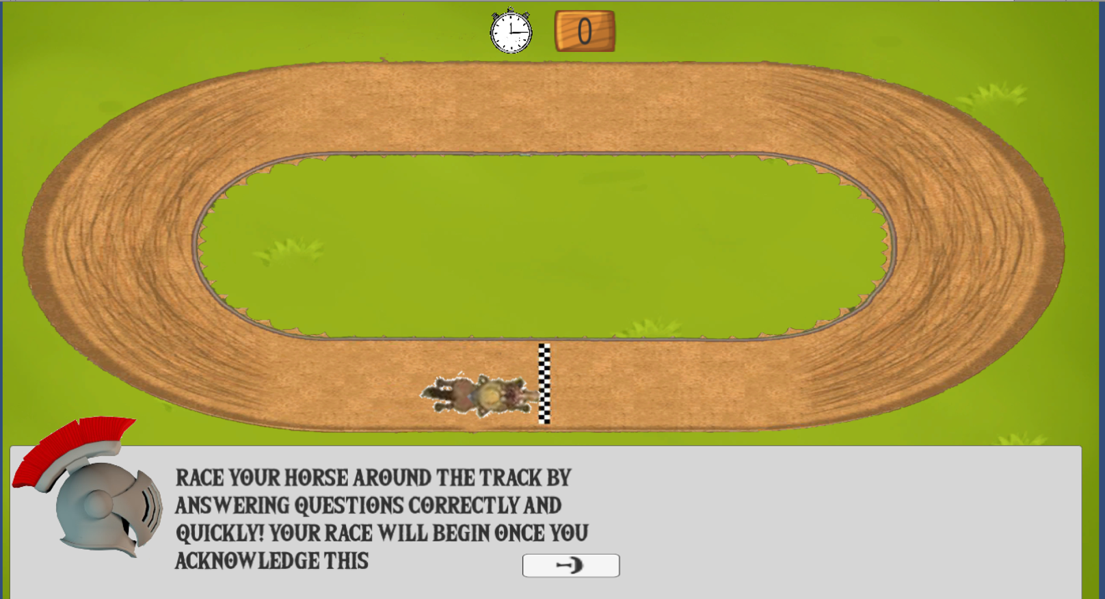
12. After clicking the arrow, the timer will start immediately, and you will be prompted to answer questions as quickly as possible. (Image example below) 